**University of Barishal**

***Assignment***

Course Name: Computer Fundamental & Office Application

Topic :Mastering Microsoft Word Features

**Submitted To:**

Tania Islam

Assistant Professor

Computer science and engineering

University of Barishal

**Submitted By:**

Name : **MD RABIUL HASAN**

Roll : 03

Batch : 47

Department : Management Studies

Date of Submission:15-11-2024

**Table of Contents**

History of Bangladesh cricket 3

Introduction 3

Background 3

Key Players and Achievements 3

Conclusion 4

Citation and references 4

References 5

# History of Bangladesh cricket

# Introduction

Bangladesh, located in South Asia, is known for its rich culture, history, and natural beauty. One of the country's most prominent cultural aspects is its love for cricket, which has grown over the years to become a national passion and source of pride.

# Background

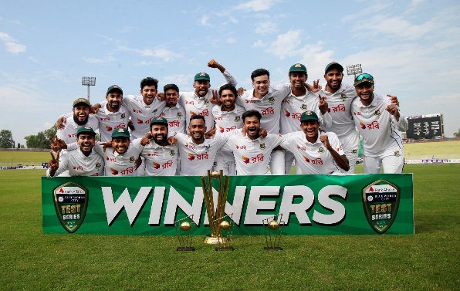Cricket in Bangladesh has a relatively young history. *The Bangladesh Cricket Board (BCB)* was established in 1972. However, it wasn't until 2000 that Bangladesh was granted Test status, becoming the *tenth Test-playing nation*. Initially, the national team faced numerous challenges, often losing to more experienced teams. Despite these setbacks, Bangladesh's players and management remained committed to improving the team's performance.

Figure 1 Cricket Player

The early struggles gave way to improvement in the early 2010s. Bangladesh started securing victories against some of the world's top cricket teams, including Australia, England, and India. These victories were significant for boosting the team's confidence and placing Bangladesh on the global cricket map.

# Key Players and Achievements

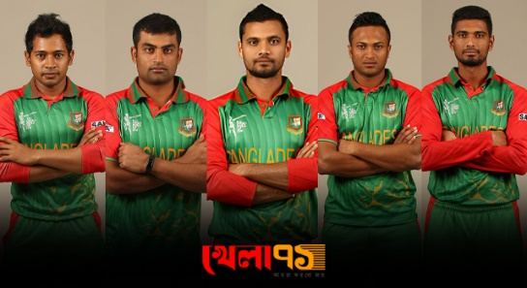The presence of talented players like Shakib Al Hasan, Mushfiqur Rahim, and Tamim Iqbal has been instrumental. Shakib Al Hasan, a world-class all-rounder, has consistently ranked among the best in international cricket. These players have inspired countless young Bangladeshis to take up cricket, further strengthening the nation's talent pool.

In One Day, Internationals (ODIs), Bangladesh has shown significant progress. Notably, reaching *the quarter-finals of the 2015 ICC Cricket World Cup was a historic achievement*, bringing immense pride to the nation and signalling their growing prowess in international cricket.

Figure 2 Ponchopandob

# Conclusion

Cricket in Bangladesh is much more than a sport; it is a vital part of the national identity. The enthusiasm and dedication of the players, along with the unwavering support of passionate fans, continue to drive the sport forward. As cricket grows and evolves in Bangladesh, it remains a powerful unifying force, bringing people together from all walks of life to celebrate and support their beloved national team.

Here's a 2x3 table with a list of exercise types and their benefits:

|  |  |
| --- | --- |
| Exercise Type | Benefits |
| Cardio | Improves heart health, burns calories |
| Strength Training | Builds muscle, increases metabolism |
| Yoga | Enhances flexibility, reduces stress |

# Citation and references

The General Data Protection Regulation (GDPR) will come into force in the European Union (EU) in May 2018 to meet current challenges related to personal data protection and to harmonise data protection across the EU. Although the GDPR is anticipated to benefit companies by offering consistency in data protection activities and liabilities across the EU countries and by enabling more integrated EU-wide data protection policies, it poses new challenges to companies. They are not necessarily prepared for the changes and may lack awareness of the upcoming requirements and the GDPR’s coercive measures. The implementation of the GDPR requirements demands substantial financial and human resources, as well as training of employees; hence, companies need guidance to support them in this transition. The purposes of this study were to compare the current Data Protection Directive 95/46/EC with the GDPR by systematically analysing their differences and to identify the GDPR’s practical implications, specifically for companies that provide services based on personal data(Tikkinen-Piri et al., 2018).

# References

Tikkinen-Piri, C., Rohunen, A., & Markkula, J. (2018). EU General Data Protection Regulation: Changes and implications for personal data collecting companies. *Computer Law & Security Review*, *34*(1), 134–153. https://doi.org/10.1016/j.clsr.2017.05.015